**Project Title: Deploy Angular Application in Docker Container**

**Install Angular application:**

root@hari6867gmail:~# sudo apt-get update

Hit:1 http://azure.archive.ubuntu.com/ubuntu xenial InRelease

Get:2 http://azure.archive.ubuntu.com/ubuntu xenial-updates InRelease [109 kB]

Get:3 http://azure.archive.ubuntu.com/ubuntu xenial-backports InRelease [107 kB]

Hit:4 http://dl.google.com/linux/chrome/deb stable InRelease

Hit:5 http://repo.zabbix.com/zabbix/3.2/ubuntu xenial InRelease

Hit:6 http://ppa.launchpad.net/ansible/ansible/ubuntu xenial InRelease

Get:7 http://security.ubuntu.com/ubuntu xenial-security InRelease [109 kB]

Ign:9 https://pkg.jenkins.io/debian-stable binary/ InRelease

Hit:10 https://pkg.jenkins.io/debian-stable binary/ Release

Hit:11 http://ppa.launchpad.net/certbot/certbot/ubuntu xenial InRelease

Hit:8 https://packages.cloud.google.com/apt kubernetes-xenial InRelease

Hit:12 http://ppa.launchpad.net/linuxuprising/java/ubuntu xenial InRelease

Hit:13 http://ppa.launchpad.net/remmina-ppa-team/freerdp-daily/ubuntu xenial InRelease

Hit:15 http://ppa.launchpad.net/ubuntu-mozilla-security/ppa/ubuntu xenial InRelease

Hit:16 http://ppa.launchpad.net/webupd8team/java/ubuntu xenial InRelease

Fetched 325 kB in 1s (199 kB/s)

Reading package lists... Done

W: Target Packages (Packages) is configured multiple times in /etc/apt/sources.list:8 and /etc/apt/sources.list.d/jenkins.list:1

W: Target Translations (en_US) is configured multiple times in /etc/apt/sources.list:8 and /etc/apt/sources.list.d/jenkins.list:1

W: Target Translations (en) is configured multiple times in /etc/apt/sources.list:8 and /etc/apt/sources.list.d/jenkins.list:1

W: Target Packages (Packages) is configured multiple times in /etc/apt/sources.list:8 and /etc/apt/sources.list.d/jenkins.list:1

W: Target Translations (en_US) is configured multiple times in /etc/apt/sources.list:8 and /etc/apt/sources.list.d/jenkins.list:1

W: Target Translations (en) is configured multiple times in /etc/apt/sources.list:8 and /etc/apt/sources.list.d/jenkins.list:1

root@hari6867gmail:~# **curl -sL https://deb.nodesource.com/setup_10.x | sudo -E bash -**

## Installing the NodeSource Node.js 10.x repo...

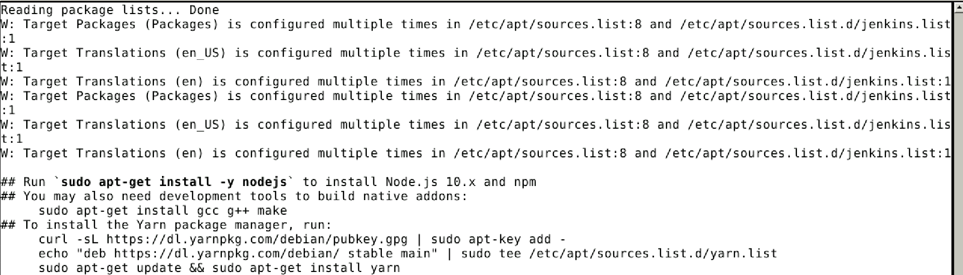

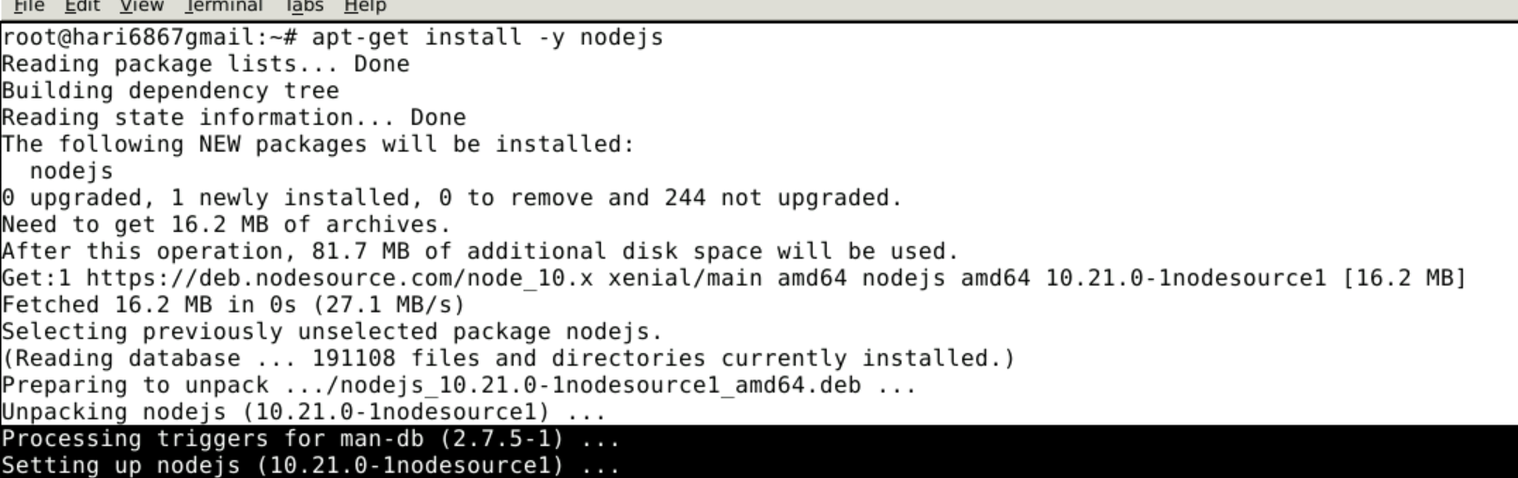

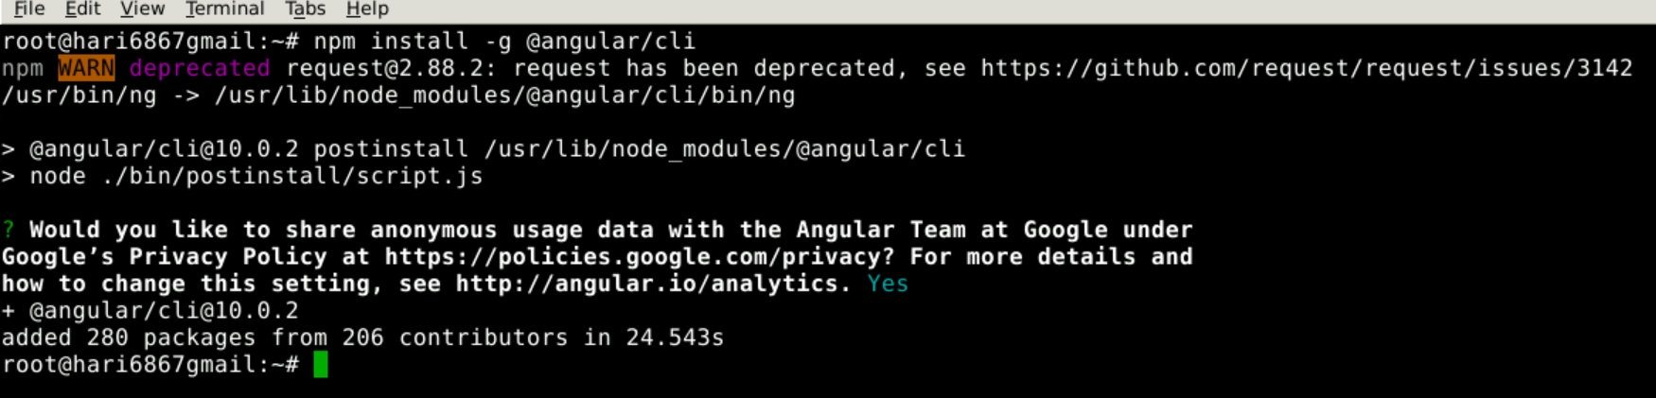

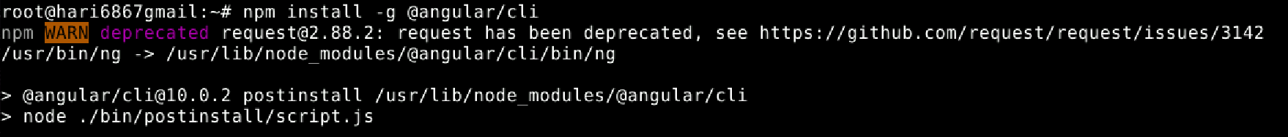

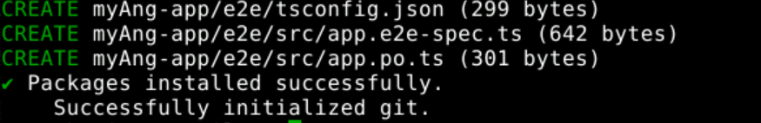

Build and tag the docker image.

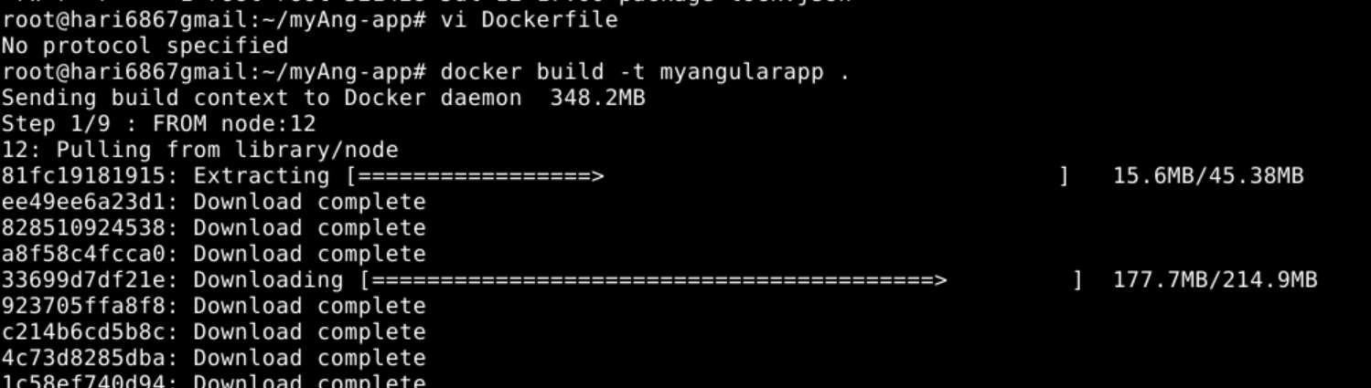

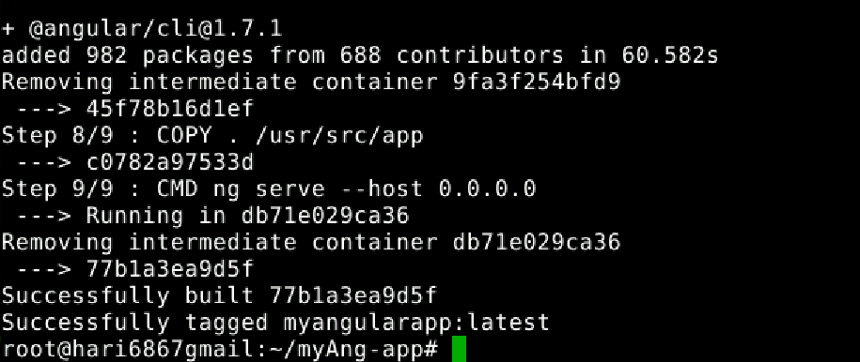

**Angular application in docker detach mode:**



**Angular application WebUI on port 4200** :

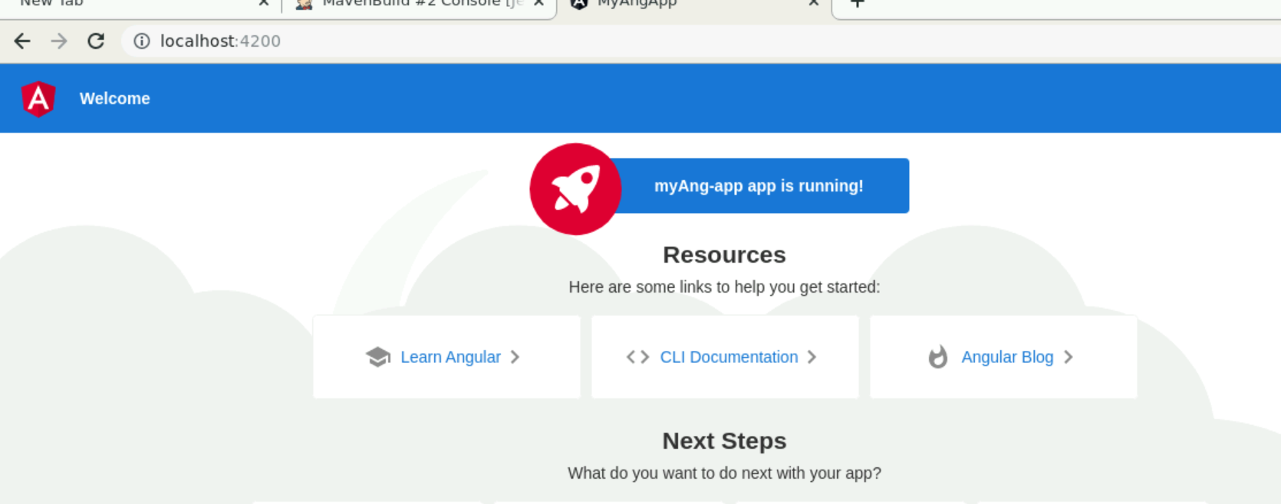

**Docker Image for New Angular application Created**:

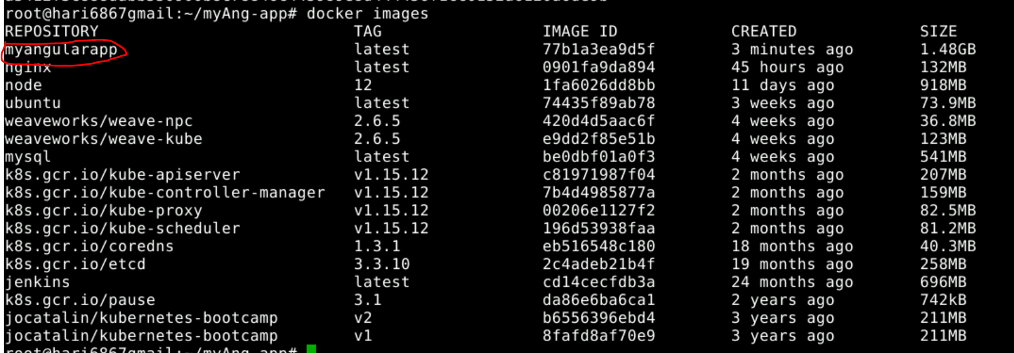

**Docker container status for Angular application:**

